Distributive Numeral Adjectives

🔹 What Are Distributive Numeral Adjectives?
# Source: AI Source: Provided by: [Data Path: Persons Table -> ID Column: 1, Name_En Column: Motasem Essam] -> From: [Chatgpt (GPT-4-turbo)] on [7/27/2025]
Distributive numeral adjectives refer to individual members of a group separately, not collectively.
They emphasize each person or thing one at a time rather than as a whole.

✅ Common Distributive Numeral Adjectives
# Source: AI Source: Provided by: [Data Path: Persons Table -> ID Column: 1, Name_En Column: Motasem Essam] -> From: [Chatgpt (GPT-4-turbo)] on [7/27/2025]
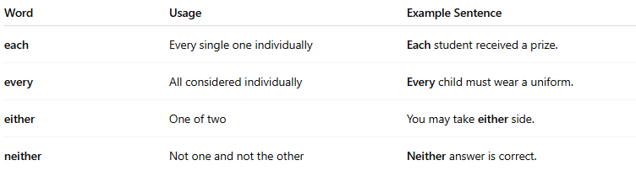
Word | Usage | Example Sentence
each | Every single one individually | Each student received a prize.
every | All considered individually | Every child must wear a uniform.
either | One of two | You may take either side.
neither | Not one and not the other | Neither answer is correct.

🧠 Key Features
# Source: AI Source: Provided by: [Data Path: Persons Table -> ID Column: 1, Name_En Column: Motasem Essam] -> From: [Chatgpt (GPT-4-turbo)] on [7/27/2025]
- Used to refer to members of a group individually.
- Always used before a singular noun.
✅ Each boy is here.
❌ Each boys are here.
- Often used in formal or precise speech or writing.

📚 Examples in Context
# Source: AI Source: Provided by: [Data Path: Persons Table -> ID Column: 1, Name_En Column: Motasem Essam] -> From: [Chatgpt (GPT-4-turbo)] on [7/27/2025]
- Each guest was given a welcome bag.
- Every page in the book is important.
- You can choose either dessert.
- Neither option suits the situation.

⚠️ Difference from Indefinite Adjectives
# Source: AI Source: Provided by: [Data Path: Persons Table -> ID Column: 1, Name_En Column: Motasem Essam] -> From: [Chatgpt (GPT-4-turbo)] on [7/27/2025]
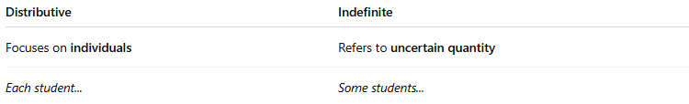
Distributive | Indefinite
Focuses on individuals | Refers to uncertain quantity
Each student... | Some students...

